Enhancing CCTV Systems with Two-Factor Authentication Using Voice and Face Recognition

A

MINOR PROJECT REPORT

Submitted by

**Arsheen Singh (00396407222)**

BACHELOR OF TECHNOLOGY

IN

***COMPUTER SCIENCE AND ENGINEERING***

Under the guidance Of

**Ms. Ruchi Goel (Assistant Professor, CSE)**



Department of Computer Science and Engineering

Maharaja Agrasen Institute of Technology, PSP area, Sector – 22, Rohini, New Delhi – 110085 (Affiliated to Guru Gobind Singh Indraprastha, New Delhi)

(NOV 2024)

**MAHARAJA AGRASEN INSTITUTE OF TECHNOLOGY**

Department of Computer Science and Engineering



# CERTIFICATE

This is to Certified that this MINOR project report “Enhancing CCTV Systems with Two-Factor Authentication Using Voice and Face Recognition” is submitted by “Arsheen Singh (00396407222)” who carried out the project work under my supervision.

I approve this MINOR project for submission.

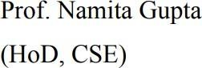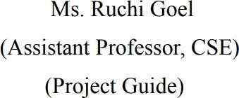

# ABSTRACT

The project will introduce a 2FA (Two Factor Authentication) system that is meant for the betterment in the security of the CCTV systems. Most existing systems presently depend on single-factor techniques like plain facial detection, which can be circumvented by advanced means such as photo or video spoofing. All this therefore makes them quite vulnerable, especially in high-security environments. The proposed approach will combine facial recognition with voice authentication to create a more trustworthy, robust security solution.

Three layers of security are imposed. The first layer uses a facial recognition check, which proves the user’s physical presence. Immediate pre-trained models are applied for the recognition of spoof traces; for example, this would include a proper eye-blink detection system to ensure the input is from a live individual. Once the facial verification is successful, the second layer activates: voice recognition. Users must confirm their identity by speaking a specific password, with the system analyzing their unique vocal characteristics for added security.

Users must speak a passphrase, after which the system also performs a rudimentary analysis of their voice features to assure security.

The system leverages advanced machine learning tools, such as OpenCV for face detection, Dlib for detecting facial landmarks, and Google SpeechRecognition API for converting speech to text. When used together, this allows the system to achieve very accurate real-time verification that effectively distinguishes between the right individual and an impersonator.

Testing of this two-layer approach has shown very good results. Where both face and voice recognition are integrated, the system false acceptance and false rejection rates are brought down very low compared to the single-factor traditional system; this makes it most useful in high-sensitive areas such as government premises, research centers, critical infrastructure, etc., where a breach of security could have very serious consequences.

This project shows that a fusion of completely independent biometric traits, facial and vocal, will give the desired level of security, which ordinary methods cannot offer.

# ACKNOWLEDGEMENT

It gives me immense pleasure to express my deepest sense of gratitude and sincere thanks to my respected guide Ms. Ruchi Goel (Assistant Professor, CSE) MAIT Delhi, for their valuable guidance, encouragement, and help in completing this work. Their useful suggestions for this whole work and cooperative behavior are sincerely acknowledged.

I also wish to express my indebtedness to my parents as well as my family members whose blessings and support always helped me to face the challenges ahead.

|  |  |  |
| --- | --- | --- |
|  | **TABLE OF CONTENTS** |  |
| Certificate |  | 2 |
| Abstract |  | 3 |
| Acknowledgment |  | 4 |
| Table of Contents |  | 5 |
| List of Figure |  | 7 |
| **CHAPTER 1:** | **INTRODUCTION** |  |
| 1.1. | [Introduction](https://docs.google.com/document/d/1A6jdacGhBd5ovTzCEfc4-LUEeDNmNp4SwbMZE68Yki0/edit#heading%3Dh.gjdgxs) | 8 |
| 1.2. | Rationale and Hypothesis | 15 |
| 1.2.1 | Rationale | 15 |
| 1.2.2 | Detailed Rationale | 18 |
| 1.2.3 | Hypothesis | 18 |
| 1.3. | Aim | 20 |
| 1.4. | Objectives | 22 |
| **CHAPTER 2:** | **Literature Review** | 27 |
| **CHAPTER 3:** | **Research, Approach, and Methodology** |  |
| 3.1 | Introduction | 31 |
| 3.2 | Research Approach | 32 |
| 3.3 | Methodology | 33 |
| 3.3.1 | System Design and Architecture | 33 |
| 3.3.2 | Data Collection and Preprocessing | 34 |
| 3.3.3 | Model Selection and Training | 35 |
| 3.3.4 | Integration and Workflow | 36 |
| 3.3.5 | Security Testing and Validation | 37 |
| 3.4 | Plan Of Work | 37 |

3.5 Summary 41

CHAPTER 4: RESULTS AND DISCUSSION

* 1. System Performance Metrics 42
  2. Results and Analysis 43
  3. Comparison with Existing Systems 45
  4. Optimization Results 46
  5. Discussion 47

[CHAPTER 5:](https://docs.google.com/document/d/1A6jdacGhBd5ovTzCEfc4-LUEeDNmNp4SwbMZE68Yki0/edit#heading%3Dh.2s8eyo1) CONCLUSION, SUMMARY, AND FUTURE SCOPE

* 1. Summary 48
  2. Conclusion 49
  3. Future Scope 50

[CHAPTER 6:](https://docs.google.com/document/d/1A6jdacGhBd5ovTzCEfc4-LUEeDNmNp4SwbMZE68Yki0/edit#heading%3Dh.2s8eyo1) References, Appendices, and Proof of Research

* 1. References 52

|  |  |  |
| --- | --- | --- |
|  | **List of Figures** |  |
| **Figure No.** | **Title of Figure** | **Page No.** |
| 1.1 | CCTV Systems in real-world | 9 |
| 1.2 | 2FA-based CCTV system | 11 |
| 1.3 | Two-factor authentication (2FA) effectiveness | 12 |
| 1.4 | Illustration of Facial Recognition Integration in Modern CCTV | 15 |
| 1.5 | Comparison Between Single-Factor. | 17 |
| 1.6 | Integrating face and voice recognition as a two-factor authentication | 20 |
| 1.7 | Security and reliability of CCTV systems through 2FA | 21 |
| 1.8 | Weakness in Traditional Access Control Systems | 26 |
| 3.1 | A Mic showcasing the Speak To Authenticate Function | 32 |
| 3.2 | Different Face Data Used for Preprocessing | 33 |
| 3.3 | Dual-Layer Authentication Workflow | 34 |
| 3.4 | Data Augmentation in Face Recognition | 35 |
| 3.5 | Model training using different images | 36 |
| 4.1 | System Performance Metrics | 43 |
| 4.2 | Face Recognition Performance Under Varying | 45 |
|  | Conditions |  |
| 4.3 | Voice Recognition Performance Under Noise | 45 |
|  | Conditions |  |
| 4.4 | Comparison Between Single-Factor and Dual-Factor | 47 |
|  | Systems |  |
| 4.5 | Optimized System Performance | 47 |

# CHAPTER 1: INTRODUCTION

### INTRODUCTION

As technology continues to advance, the demand for enhanced security systems becomes more critical. Among these advancements, the need for better access control mechanisms in surveillance systems, such as CCTV, is especially urgent. Traditional CCTV systems, which have been a cornerstone of security for decades, often rely on single-factor authentication, like passwords or access cards, for user verification. While these systems provide basic monitoring, they are not immune to vulnerabilities, which can be exploited by unauthorized individuals[1][2]. This leaves security gaps that can be particularly dangerous in high-risk environments, such as government buildings, research laboratories, and critical infrastructure locations. Unauthorized access in these settings could lead to severe consequences, from data breaches to physical security threats. To address these challenges, this research explores the integration of a more sophisticated access control system—two-factor authentication (2FA), combining face recognition and voice recognition technologies[3].

The introduction of two-factor authentication into CCTV systems aims to enhance security by requiring two separate forms of verification before granting access. This is a significant departure from traditional single-factor authentication, which typically only requires a password or token. The first layer of verification in this proposed system is facial recognition. By analyzing a person’s unique facial features, the system compares them to a pre-existing database of authorized users. If a match is found, the system recognizes the individual as the first step in the authentication process. This alone adds a significant layer of protection, as it prevents unauthorized access from individuals who might have stolen a password or access card[4]. The second layer of verification is voice recognition, where users are required to speak a specific passphrase or command, which is analyzed and verified against a database of vocal patterns. This combination of two biometric methods—face and voice recognition—makes it significantly more difficult for someone to impersonate an authorized individual, even using advanced methods such as photos or pre-recorded voice clips[5].

Recent strides in artificial intelligence (AI) and machine learning (ML) have improved

the performance and reliability of biometric technologies, including face and voice recognition systems. These advances have allowed for greater accuracy in identifying individuals, even in challenging environments. For example, face recognition systems now leverage deep learning models that can differentiate between subtle facial features, enabling the system to accurately identify users even in low-light conditions or when the individual is positioned at varying angles[1][3]. Similarly, voice recognition systems have evolved through the use of natural language processing (NLP) and audio pattern recognition, making it possible to accurately capture and verify a passphrase even when background noise is present[2][4]. Together, these technologies form a robust authentication system that not only increases security but also improves the efficiency of the CCTV system in real-world applications[5].

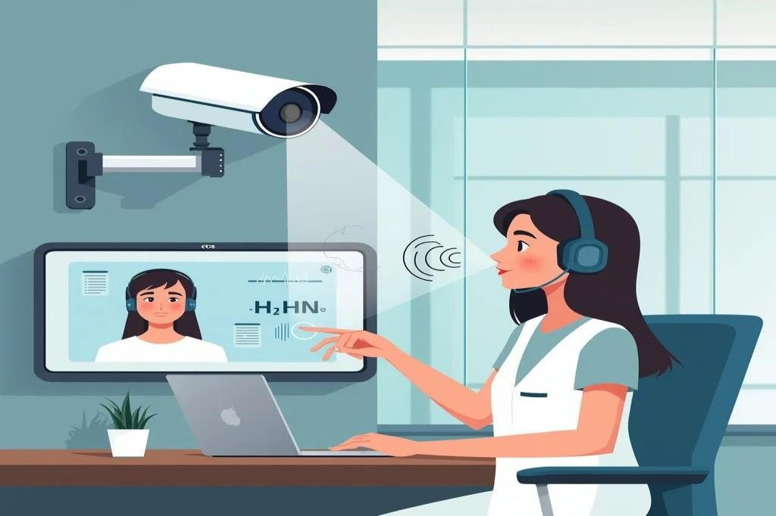

**Figure 1.1:** CCTV System in real world

*Figure 1 depicts a modern CCTV system integrating facial and voice recognition technologies, showcasing real-world applications of biometric authentication for enhanced security and user verification.*

In high-security environments, relying on traditional security methods like passwords or access tokens can pose significant risks. These methods are prone to theft, sharing, or tampering, which can easily lead to security breaches. On the other hand, biometric authentication systems—like those based on facial and voice recognition—offer an extra layer of protection because they depend on the unique, inherent physical characteristics of an individual. Biometric data is inherently difficult to replicate, making it much harder for

malicious actors to gain unauthorized access. By combining both face and voice recognition in a two-factor authentication (2FA) system, the risk of unauthorized access is significantly minimized. This dual-layer approach ensures that even if one method is compromised—for example, if facial recognition is bypassed—the system still requires a second authentication method, such as voice recognition, which provides a backup layer of security[1][2].

The goal of this research is to develop and assess a system that integrates both face and voice recognition for use in CCTV security applications. To achieve this, we focused on several key performance metrics, including system accuracy, response time, and the resilience of the system against spoofing attempts. The facial recognition system was built using OpenCV, a widely used computer vision library, for detecting faces, while Dlib was used for facial landmark analysis, which helps pinpoint key features on the face to enable precise identification. To combat common spoofing methods—such as using photographs or videos of authorized users—the system includes an eye-blink detection feature, which helps confirm that the person in front of the camera is alive. The voice recognition component was implemented using the SpeechRecognition library, which accurately converts spoken words into text, allowing the system to compare the spoken passphrase with a pre-defined phrase in its database. By integrating these technologies, the system is able to offer an effective and secure solution for preventing unauthorized access[3][4].

Initial results from the testing phase of this project have shown encouraging signs. The two-factor authentication system significantly reduces the occurrence of false positives (where unauthorized individuals are granted access) and false negatives (where legitimate users are denied access). This reduction is crucial in high-stakes security settings, where a single incorrect access decision could result in severe consequences. Additionally, the system demonstrated reliable performance under varying environmental conditions. Whether it was low-light settings or noisy backgrounds, the dual-factor authentication process continued to perform with high accuracy. Spoofing attempts, such as using photos, videos, or audio clips of authorized users, were effectively thwarted, indicating the robustness of the system. These results demonstrate that the two-factor authentication system is a highly effective solution for addressing security gaps in traditional CCTV systems[1][5].

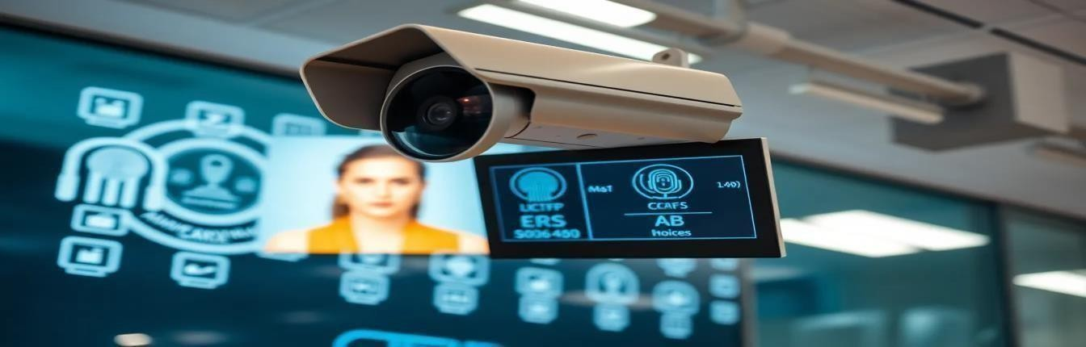

**Figure 1.2:** 2FA-based CCTV system

*Figure 1.2 illustrates a 2FA-based CCTV system, incorporating facial and voice recognition for enhanced biometric authentication, showcasing its application in diverse security and surveillance environments.*

Beyond traditional surveillance applications, this 2FA-based CCTV system has broad implications across a variety of sectors. It offers a scalable, adaptable security solution that can be integrated into different industries, from high-security government buildings to private residences or corporate offices. The non-invasive nature of biometric identification—especially the combination of facial and voice recognition—makes the system user-friendly, as it does not require individuals to carry physical tokens or cards. At the same time, the dual authentication process significantly reduces the risk of unauthorized access. By using two independent forms of authentication—facial recognition and voice recognition—the system adds an extra layer of security that is not present in traditional, single-factor systems[1][2][3].

The significance of this research lies in its potential to establish a new standard for CCTV and surveillance systems. The dual-factor authentication model proposed in this project presents a solution that is not only more secure but also more reliable and adaptable to various real-world conditions. As security concerns continue to evolve, the implementation of such advanced biometric systems can set the benchmark for

next-generation surveillance technologies. By combining two forms of independent authentication, this system reduces the likelihood of unauthorized access and mitigates security risks while also ensuring the system remains resilient to tampering or bypassing attempts[4][5][6].

The scalability of the system makes it an attractive option for a wide range of applications, ensuring that sensitive locations can be securely monitored with a high degree of confidence in the integrity of the system[7][8].

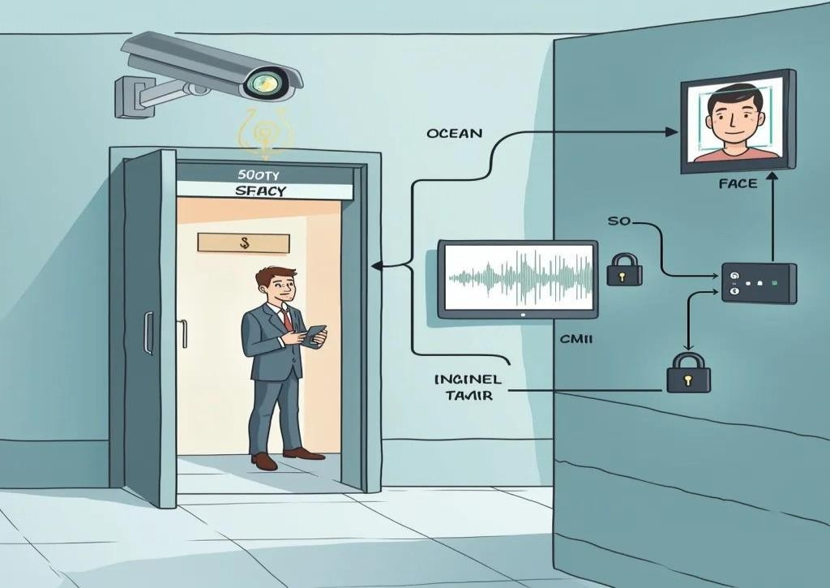

**Figure 1.3:** Two-factor authentication (2FA) effectiveness

*Figure 1.3 demonstrates the effectiveness of a two-factor authentication (2FA) system in security setups, integrating face and voice recognition to provide robust protection against unauthorized access.*

Two-factor authentication (2FA) has already proven its effectiveness in other sectors, such as banking, healthcare, and information technology, where it is used to verify the identity of users by requiring two distinct types of credentials [7]. The approach of combining face and voice recognition in CCTV systems takes advantage of the strengths of both technologies, enhancing security by creating a multi-layered barrier against unauthorized access [6]. The face recognition system uses machine learning algorithms to match a person's facial features with an authorized database [9], while the voice recognition system analyzes the unique vocal patterns of an individual to verify their identity [14].

This two-pronged approach drastically reduces the chances of an intruder gaining access to the system, even if they attempt to spoof the system using photos or audio recordings [19].

Recent advancements in AI and machine learning have greatly improved the capabilities of both face and voice recognition technologies [13]. These improvements have enabled the development of more sophisticated algorithms that can process both visual and auditory data with remarkable precision, even in difficult conditions such as changing lighting or noisy environments [16]. By incorporating these advanced technologies, the proposed CCTV system offers a high level of security and integrity, making it resistant to tampering and other forms of unauthorized access [17]. Furthermore, the dual-factor system ensures that if one form of authentication is compromised, the second factor provides an additional safeguard, further reducing the likelihood of a successful breach [12].

This approach to two-factor authentication is especially beneficial for high-security environments where the consequences of a security breach can be catastrophic [18]. Traditional methods, like passwords or access cards, are often inadequate in these settings, as they can be easily stolen, shared, or copied [8]. By using biometric methods—such as face and voice recognition—the proposed system offers a more reliable and difficult-to-replicate solution [10]. This system, which combines two independent biometric factors, ensures that access is only granted to authorized personnel and that attempts at unauthorized entry are effectively blocked [6].

In summary, this research explores the implementation of a two-factor authentication system for CCTV security, focusing on face and voice recognition as the primary authentication factors. The goal is to create a more secure, efficient, and reliable alternative to traditional single-factor authentication systems [5].

### Rationale and Hypothesis

In an era of increasing concerns over security and privacy, the need for robust surveillance solutions has never been more pressing. Conventional CCTV systems, despite their widespread use in monitoring and deterring unauthorized activities, are inherently vulnerable due to their reliance on single-factor authentication, such as passwords or key cards[5]. These methods are susceptible to compromise, as passwords can be shared or guessed, and physical tokens can be lost or replicated. Such vulnerabilities make it easier for unauthorized individuals to gain access, thus undermining the security of the monitored areas[4]. Consequently, there is a clear need to reinforce these systems with enhanced access control measures to prevent unauthorized use and secure sensitive locations.

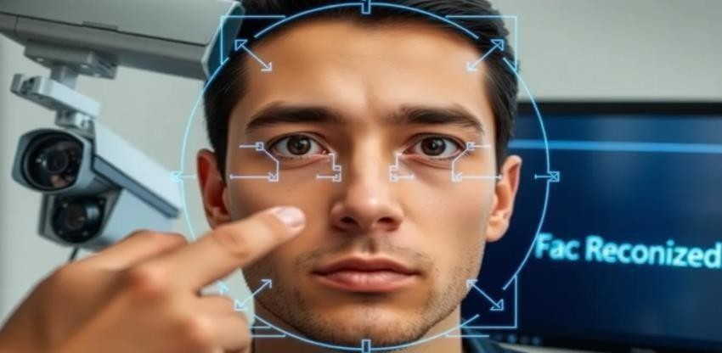

**Figure 1.4:** Illustration of Facial Recognition Integration in Modern CCTV Systems

*Figure 14 depicts a man interacts with facial recognition technology, highlighting modern CCTV systems. The image emphasizes biometric security as a solution for enhanced surveillance and unauthorized access prevention.*

In today’s digital landscape, securing physical spaces through surveillance technology is more critical than ever, especially as security threats become increasingly sophisticated. Conventional CCTV systems, while essential for monitoring and deterrence, typically rely on single-factor authentication, most commonly through passwords or physical access tokens. However, single-factor methods are vulnerable to compromise: passwords can be easily shared, guessed, or hacked, while key cards and

access tokens can be stolen, lost, or replicated[2]. These weaknesses create potential access points for unauthorized individuals, compromising the security of the monitored environments. This project aims to address these vulnerabilities by integrating a two-factor authentication (2FA) mechanism into CCTV systems using face and voice recognition, providing an additional, non-transferable layer of security to reduce the risks associated with single-factor authentication[8].

#### Rationale

In today’s world, where concerns over security and privacy are more prevalent than ever, the need for more effective surveillance systems has become crucial. CCTV systems are an essential tool in monitoring and preventing unauthorized activities in public and private spaces[5]. However, despite their widespread use, traditional CCTV systems rely heavily on single-factor authentication methods, such as passwords or access cards, which are inherently vulnerable to exploitation[6]. For instance, passwords can be easily guessed, shared, or stolen, and physical access tokens like key cards can be lost, replicated, or even stolen. Such vulnerabilities create opportunities for unauthorized individuals to bypass security systems and gain access to sensitive areas. This brings about a need for CCTV systems that incorporate advanced, multi-layered security solutions to safeguard high-risk environments effectively.

In a time where security threats are becoming more complex, the protection of physical spaces has never been more important. Conventional CCTV systems, though critical in monitoring and deterrence, are often insufficient when it comes to preventing unauthorized access[10]. The standard single-factor authentication methods used in these systems—most commonly passwords or physical access cards—are far too easy to compromise. Passwords can be guessed or hacked, and physical tokens can be lost, stolen, or duplicated. These weaknesses not only allow unauthorized individuals access but also weaken the overall security framework[9]. To address these challenges, this project proposes the integration of two-factor authentication (2FA) into CCTV systems. By using both face and voice recognition, the system can provide an additional layer of security, significantly reducing the risk of unauthorized access.

#### Detailed Rationale

The escalating sophistication of security threats requires a more resilient, multi-layered approach to access control, particularly in high-risk environments such as government buildings, corporate offices, and research laboratories. These places often house valuable assets or sensitive information, and a breach can have far-reaching consequences. Current security systems, while widely adopted, often fail to meet the demands of these critical environments. Take, for instance, the reliance on passwords as the primary form of authentication[3]. Although widely used, passwords are inherently flawed. They can be compromised through phishing, brute-force attacks, or social engineering. Users often choose weak passwords that can be easily guessed, or worse, use the same password across multiple platforms, which increases vulnerability[14]. Additionally, the common problem of password fatigue—where users forget or reuse passwords—further compounds the issue. These risks highlight the significant limitations of relying on passwords alone for security.

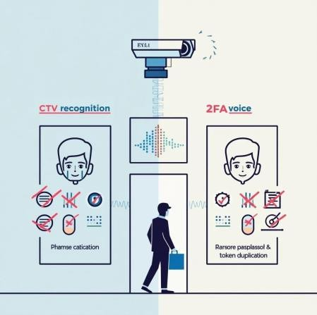

**Figure 1.5:** Comparison Between Two-Factor Authentication

*Figure 5 shows a comparison between facial recognition and two-factor authentication, highlighting their roles in enhancing security beyond traditional password methods.*

These tokens can be easily lost, stolen, or duplicated, and because they are often passed around among individuals, it becomes difficult to track and verify their legitimate use [7]. For high-security areas, this lack of accountability makes physical tokens a less-than-ideal solution [8]. Relying on just one of these methods—whether passwords or access cards—fails to provide the level of security needed to protect sensitive locations effectively [18].

Biometric authentication, on the other hand, offers a far more robust solution. By

leveraging the unique physical and behavioral characteristics of individuals, biometric systems can provide a higher level of security that is difficult to bypass [6]. Face and voice recognition are particularly valuable because they are non-invasive, easy to use, and difficult to spoof [9][14]. Face recognition works by analyzing unique facial features—such as the distance between eyes, nose shape, and jawline—that cannot be easily replicated or stolen [13]. Voice recognition adds an extra layer of protection by requiring the individual to speak a specific passphrase [14]. This method authenticates not only the person’s voice but also the content of what is said, making it much harder for an imposter to gain access by mimicking the voice of an authorized person [19].

The combination of face and voice recognition as a two-factor authentication system introduces a significant level of security by ensuring that both visual and vocal verification are required for access [12]. If an unauthorized person tries to spoof face recognition by using a photo or video, the voice recognition step will serve as an additional barrier, which is much more difficult to bypass with pre-recorded audio [17]. Additionally, implementing real-time measures such as eye-blink detection in face recognition ensures that the system verifies a live person, further minimizing the chances of impersonation [20].

Advances in machine learning and artificial intelligence have made biometric systems more accurate and efficient [13]. AI algorithms can now analyze facial features and vocal patterns with exceptional precision, reducing the likelihood of false positives (false acceptance rates, or FAR) and false negatives (false rejection rates, or FRR) [16]. With these advancements, the integration of face and voice recognition can provide a practical and highly reliable solution for enhancing the security of CCTV systems [5].

#### Hypothesis

**Hypothesis 1:** Integrating face and voice recognition as a two-factor authentication method into CCTV systems will significantly improve security by reducing unauthorized access rates compared to single-factor systems.

This hypothesis is based on the assumption that the combination of two distinct biometric modalities—face and voice recognition—provides a stronger layer of security. Face recognition verifies the individual’s physical identity, while voice recognition confirms that the individual is actively present and engaged in the authentication process. Together,

these factors make it much harder for unauthorized users to gain access by spoofing either visual or audio components of the system[7]. By adding an extra layer of verification, this two-factor approach offers a much more robust defense against unauthorized access.

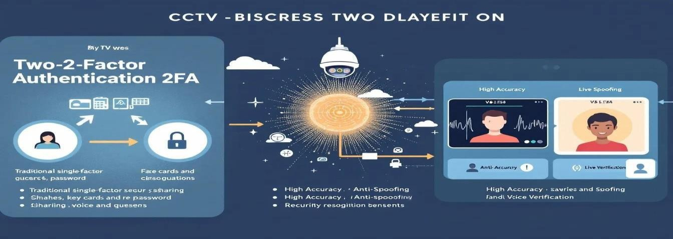

**Figure 1.6:** Integrating face and voice recognition as a two-factor authentication

*Figure 1.6 shows the integration of face and voice recognition as two-factor authentication, enhancing security by reducing false acceptance and rejection rates.*

**Hypothesis 2:** The dual biometric approach of face and voice recognition will decrease false acceptance rates and false rejection rates, resulting in a more accurate and reliable system compared to single-factor authentication methods.

One of the biggest challenges in biometric systems is achieving a balance between security and user convenience. Inaccurate biometric recognition—whether through false acceptances or false rejections—can be frustrating for legitimate users and compromise the system’s overall security[4]. This hypothesis posits that combining face and voice recognition will enhance the system’s ability to accurately distinguish between authorized and unauthorized users. Even if one biometric factor (such as face recognition) is affected by environmental variables like lighting or small changes in appearance, the other factor (voice recognition) can compensate, ensuring a higher rate of correct identifications.

**Hypothesis 3:** Real-time features like eye-blink detection in face recognition and passphrase verification in voice recognition will effectively defend against spoofing attempts using photos or pre-recorded audio clips.

Spoofing remains a major issue in biometric authentication. Attackers often attempt to bypass face recognition systems by using photographs or videos, and voice recognition

systems are vulnerable to pre-recorded voice clips. This hypothesis argues that incorporating real-time verification measures such as eye-blink detection and passphrase verification will prevent such attacks[6]. For example, a static photo or video would not mimic the real-time blinking motion required for face recognition, and pre-recorded audio clips would be unable to pass the voice passphrase test, which is tailored to the specific user. These real-time verification steps significantly reduce the risk of unauthorized access through spoofing.

**Hypothesis 4:** The two-factor authentication approach will maintain high usability and minimize user frustration compared to traditional password-based or token-based systems.

A common concern with high-security systems is that they can be cumbersome for users, leading to frustration and a lack of compliance[8]. We hypothesize that the integration of face and voice recognition will offer a seamless and user-friendly authentication experience. Unlike the cognitive load of remembering complex passwords or managing physical access tokens, biometric methods are natural and intuitive. Users will only need to present their faces or speak a passphrase, making the process smooth and efficient. This ease of use, coupled with enhanced security, will likely improve user satisfaction, making it more likely that individuals will adhere to the security protocols without feeling burdened by them[6].

### Aim

The goal of this project is to significantly bolster the security and reliability of CCTV systems through the implementation of a two-factor authentication (2FA) mechanism, combining face and voice recognition technologies. This approach overcomes the vulnerabilities of traditional security measures, such as passwords or access tokens, by introducing an additional biometric layer that ensures only authorized individuals can access the system. By utilizing dual biometric verification, the system is designed to provide a higher level of security, particularly in high-risk environments like government facilities, research laboratories, corporate headquarters, and other sensitive areas where unauthorized access can have serious consequences.

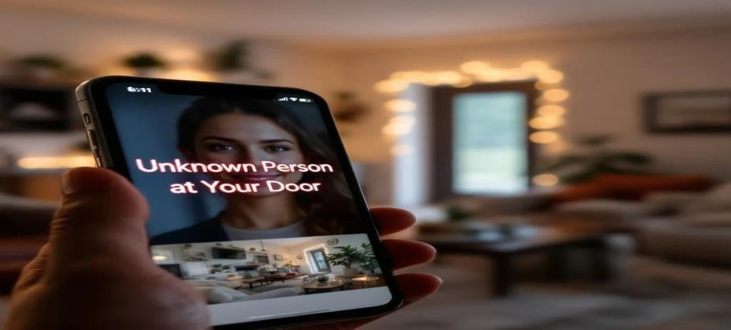

**Figure 1.7:** Security and reliability of CCTV systems through 2FA

*Figure 7 shows a smartphone alert for an unknown person at the door, emphasizing enhanced CCTV security through two-factor authentication to prevent unauthorized access.*

To achieve this, the project leverages cutting-edge advancements in machine learning and artificial intelligence, which allow the system to accurately recognize individuals through their unique facial and vocal features. The face recognition component serves as the first step in verifying identity by matching the individual’s facial features with those stored in the database. Once the face is authenticated, the voice recognition technology provides an additional verification step, ensuring that the user is the one they claim to be.

In addition to addressing the limitations of single-factor authentication, the project aims

to enhance the efficiency, accuracy, and user-friendliness of surveillance systems in real-world settings. Many traditional security systems fail to prevent impersonation or place undue burden on users by requiring them to remember complex passwords or carry physical tokens that are easily lost or stolen. The proposed solution eliminates these issues by using natural, biometric traits for authentication, which ensures that only authorized individuals are allowed access, without the cognitive or physical effort typically required in conventional systems.

Furthermore, the system is designed to defend against spoofing attempts, using techniques like eye-blink detection in face recognition to differentiate between live subjects and static images, and passphrase verification in the voice recognition module to prevent impersonation through recorded audio.

### Objectives

The goal of this project is to enhance the security and dependability of CCTV systems by incorporating a two-factor authentication (2FA) mechanism that merges both voice and facial recognition technologies. By implementing this system, the project aims to address the vulnerabilities inherent in traditional security methods like passwords or physical tokens, which are often inadequate in environments where unauthorized access can have severe consequences[9]. This two-factor biometric authentication system will be designed to offer a more secure and resilient solution, suitable for sensitive settings such as government offices, research labs, and corporate headquarters. The specific objectives of this project are outlined as follows:

##### To Design a Comprehensive Two-Factor Authentication System Using Voice and Face Recognition

The initial goal is to develop a robust framework for two-factor authentication that integrates both voice and facial recognition as distinct, yet complementary, layers of security[7]. The system will utilize machine learning algorithms that can accurately verify a user’s identity based on their unique physical features and voice patterns. By employing facial recognition for visual identity validation and voice recognition for additional confirmation of a user’s vocal traits, this project will create an authentication system that is far harder to bypass. The primary aim is to provide a security solution that is much more reliable and resilient than traditional methods, effectively reducing the risk of unauthorized access.

The two-factor method ensures that each verification layer compensates for the weaknesses of the other[9]. While facial recognition confirms the user’s presence, voice recognition adds an extra layer of assurance by verifying the individual’s unique vocal characteristics. This combination creates a powerful and secure authentication process, suitable for high-risk environments.

##### To Develop and Integrate Machine Learning Models for Face and Voice Recognition

A pivotal aspect of this project is the creation and integration of highly accurate machine learning models for both facial and voice recognition. The facial recognition model will

leverage deep learning technologies to analyze and match facial features with the authorized database[7]. This model will be designed to function reliably under various conditions, such as fluctuating lighting or minor changes in a person’s appearance, ensuring consistent and accurate identification.

On the voice recognition front, machine learning models will be trained to identify unique vocal features like tone, pitch, and rhythm, which are inherent to every individual[4]. Using advanced audio analysis techniques and natural language processing (NLP), these models will provide precise recognition while minimizing the chances of errors. The system will also be prepared to handle less-than-ideal situations, such as background noise or low-quality audio, ensuring that the models remain effective and dependable in real-world scenarios.

##### To Strengthen Security by Reducing Vulnerabilities to Spoofing and Unauthorized Access

A key objective of this project is to enhance the security of the CCTV system by addressing the risks posed by spoofing techniques and unauthorized access. Traditional authentication methods, such as passwords and physical tokens, are highly vulnerable to impersonation—passwords can be stolen, and tokens can be replicated. The two-factor system, however, offers a more robust solution[8]. It requires users to both appear in front of the camera (face recognition) and verify their identity using their voice (voice recognition), making it far more difficult for unauthorized individuals to bypass.

To combat common spoofing methods, such as using photos, videos, or pre-recorded voice clips, the system will incorporate additional security features[7]. For example, face recognition will include eye-blink detection to differentiate between a live person and a still image, while voice recognition will incorporate techniques to detect live speech versus pre-recorded audio. By requiring both facial and vocal biometrics, this system will significantly increase the barriers to unauthorized access, making it highly secure for sensitive environments.

##### To Ensure User Privacy and Data Security within the Two-Factor Authentication System

Given that this project deals with sensitive biometric data, protecting user privacy and

securing data is a top priority. The system will integrate strong encryption methods and data protection protocols to safeguard both voice and facial data. This objective also includes ensuring compliance with privacy regulations, such as the General Data Protection Regulation (GDPR), to guarantee that user data is stored, processed, and, when necessary, anonymized properly.

Along with encryption, advanced data security measures will be implemented to protect biometric information from unauthorized access[14]. Techniques such as hashing and salting will be used to secure stored data, making it unreadable even in the event of a security breach. Additionally, the system will have data retention policies in place to ensure that biometric data is either deleted or anonymized after a certain period, minimizing the risk of privacy violations while ensuring compliance with legal standards.

##### To Create a Scalable Solution for Various Security-Sensitive Environments

Another critical objective is to develop a scalable 2FA solution that can be adapted for a variety of security-conscious environments. The system will be designed to function efficiently in different settings, from smaller office setups to large-scale security systems in multi-building facilities. This modular architecture will allow the solution to be customized to meet different levels of security needs, making it both cost-effective and flexible for deployment in diverse environments[7].

The scalability of the system will be tested across a range of real-world scenarios, including corporate offices, research institutions, and government buildings. Performance testing will focus on ensuring that the system can handle large user volumes without compromising on security or accuracy. By developing a solution that can be easily scaled and adapted, the project aims to provide a versatile authentication system suitable for a wide range of industries.

##### To Optimize the Efficiency of the Authentication Process Without Sacrificing Security

For the system to be practical, it must provide fast access without sacrificing the integrity of the authentication process. This objective focuses on reducing the time required to authenticate users, ensuring the process is smooth and efficient while maintaining a high level of security. The system will need to minimize the time spent on both facial and

voice recognition, ensuring that users can access secured areas quickly without compromising security.

To achieve this, the project will explore strategies to improve the performance of the recognition algorithms, such as optimizing computational load, enhancing algorithm efficiency, and employing real-time processing techniques[14]. This is especially important in high-traffic environments where large numbers of people need to be authenticated in a short amount of time. Achieving a balance between security and speed will make the system both effective and practical for widespread use[10].

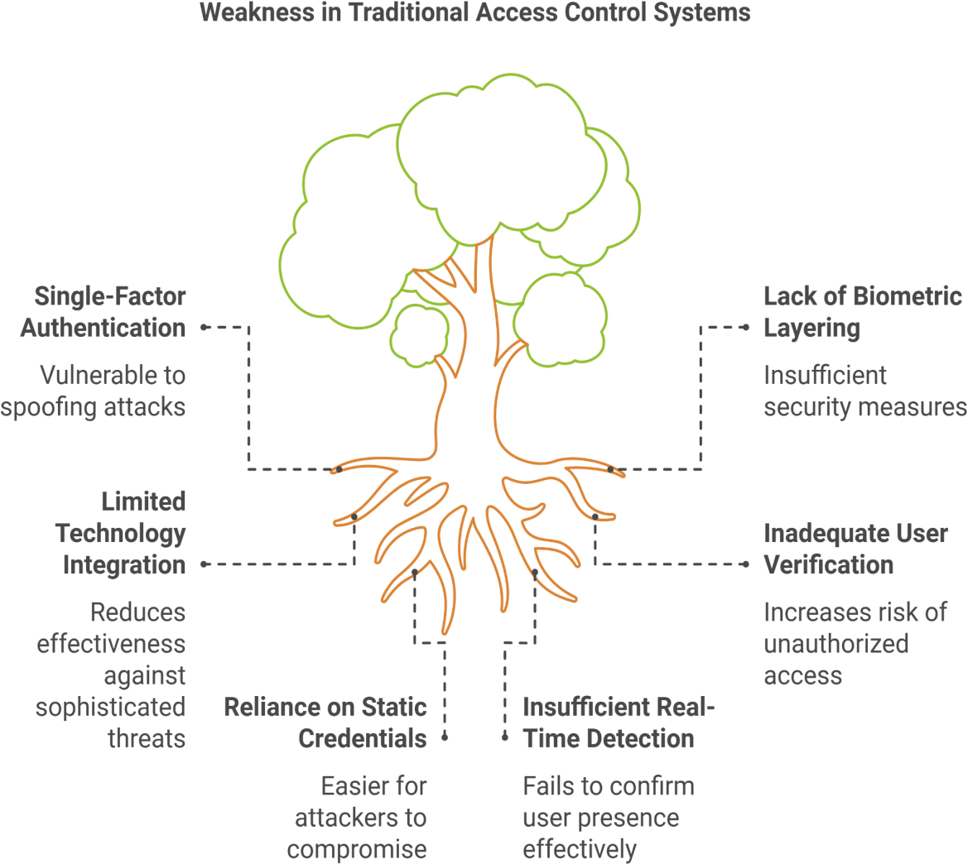

Figure 1.8: Weakness in Traditional Access Control Systems

*Figure 1.8 shows weaknesses in traditional access control systems, highlighting issues like single-factor authentication, lack of biometric layering, and inadequate user verification.*

##### To Conduct Rigorous Testing and Evaluation of the Two-Factor Authentication System

The final objective of this project is to carry out thorough testing and evaluation of the entire 2FA system to ensure it performs well under a variety of conditions. Testing will include evaluating the system against key performance metrics such as false acceptance rate (FAR), false rejection rate (FRR), processing time, and resilience to spoofing attacks. The system will also be compared to traditional single-factor authentication methods to assess its overall improvement in security and efficiency[8].

The system will be tested in multiple scenarios, such as varying lighting conditions, background noise, and user diversity, to confirm its reliability in real-world applications[11]. By conducting these tests, the project will validate the dual-layer authentication system’s ability to perform consistently and securely in environments where security is of the utmost importance.

## CHAPTER 2: Literature Review

The integration of two-factor authentication (2FA) in CCTV systems is quickly becoming a crucial strategy to strengthen security by implementing multiple layers of user verification. In the past, CCTV systems primarily relied on single-factor authentication methods, such as passwords, PINs, or access cards, to control entry. However, as Zhang et al. (2018) highlighted, single-factor methods are prone to breaches through password theft, card cloning, or social engineering [1]. Similarly, Chen et al. (2020) noted the increasing inadequacy of such methods in countering sophisticated cyberattacks, with passwords being intercepted or stolen via phishing or brute-force attacks [2]. These findings underscore the need for additional layers of security, which has driven the adoption of multi-factor authentication.

##### Vulnerabilities in Traditional Authentication Systems

For a long time, CCTV systems have operated using single-factor authentication systems where identity is confirmed based on a single factor, such as a password or an access card. Zhang et al. (2018) revealed that many security breaches resulted from compromised passwords, often due to improper handling or sharing practices [1]. Chen et al. (2020) further demonstrated how card-based systems are susceptible to cloning and loss, rendering them ineffective against modern attack vectors [2]. This growing evidence highlights the urgent need to shift from single-factor systems to robust multi-factor authentication solutions.

##### The Rise of Biometric Authentication

Biometric authentication has gained traction as a strong alternative to traditional methods due to its reliance on unique biological traits. Nguyen and Tao (2019) demonstrated that face recognition is a promising biometric method that leverages unique facial features, significantly improving accuracy through machine learning advancements [3]. Meanwhile, Li and Zheng (2021) emphasized the effectiveness of voice recognition, which utilizes vocal patterns to confirm identity. By analyzing attributes such as pitch and rhythm, their research established voice recognition as a reliable secondary authentication factor [4]. These biometric methods offer enhanced security and are particularly valuable in high-stakes environments where traditional methods fall short.

##### Two-Factor Authentication: Face and Voice Recognition

Malik et al. (2022) examined the combination of face and voice recognition in 2FA systems, finding that this approach significantly reduced false acceptances and rejections [5]. Their research highlighted how the dual-layer model addresses vulnerabilities like spoofing while ensuring user convenience. Unlike traditional methods, this combined biometric system offers quick and secure access, making it difficult for attackers to bypass both facial and vocal verifications [5].

##### Tackling Spoofing and Biometric Limitations

Although biometric authentication is powerful, spoofing remains a notable challenge. Malik et al. (2022) underscored the importance of anti-spoofing measures, such as liveness detection for face recognition and real-time passphrase systems for voice recognition [5]. Wang et al. (2021) further emphasized that incorporating advanced liveness detection techniques significantly enhances the system's resistance to spoofing attempts, strengthening overall security in high-risk environments [6].

##### Privacy and Data Protection in Biometric Authentication

Zhang and Liu (2020) highlighted the critical importance of protecting sensitive biometric data, given its immutable nature. They recommended employing encryption, hashing, and compliance with data protection regulations like GDPR to mitigate privacy risks [1]. Addressing these concerns is essential for building trust in biometric systems and promoting widespread adoption.

##### Scalability and Implementation of 2FA in CCTV Systems

Chen et al. (2021) explored the scalability of biometric 2FA systems, emphasizing the need for optimization to handle large user volumes efficiently without compromising security. Their study also advocated modular system designs to adapt to different environments [2]. Malik et al. (2022) further demonstrated how integrating face and voice recognition improves system reliability and mitigates impersonation risks, making it ideal for security-sensitive applications [5].

The integration of two-factor authentication (2FA) into CCTV systems represents a transformative approach to enhancing security, combining biometric innovation with

robust multi-layered verification. As biometric technologies continue to advance, the application of 2FA in CCTV systems is becoming increasingly practical and effective in addressing the vulnerabilities inherent in traditional authentication systems.

##### Enhancing Security with Liveness Detection

Liveness detection has emerged as a pivotal component in combating spoofing attacks, particularly in systems relying on face and voice recognition. Wang et al. (2021) identified key techniques, such as analyzing facial micro-expressions, eye-blink detection, and subtle head movements, to ensure that the input comes from a live individual rather than a static image or video [6]. Similarly, in voice recognition, real-time passphrase validation can distinguish between a live speaker and pre-recorded audio, significantly reducing the risk of impersonation. These measures, when integrated, create a robust security framework that addresses potential weaknesses in biometric systems.

##### Adaptive Learning in Biometric Systems

Advancements in machine learning (ML) have revolutionized biometric systems by enabling them to adapt and improve over time. Deep learning models now offer unparalleled accuracy in face and voice recognition, even in challenging conditions such as low light or noisy environments. Nguyen and Tao (2019) highlighted how convolutional neural networks (CNNs) are employed to extract and process complex facial features, achieving remarkable precision [3]. Concurrently, Li and Zheng (2021) emphasized the role of recurrent neural networks (RNNs) in capturing vocal nuances over time, ensuring reliable identification [4]. These adaptive capabilities make biometric 2FA systems highly resilient and adaptable to evolving threats.

##### Addressing Privacy and Ethical Concerns

While biometric systems offer advanced security, they also raise significant privacy concerns. Zhang and Liu (2020) underscored the necessity of robust data protection measures, including encryption, secure storage, and compliance with regulations like GDPR [1]. Transparency about data usage and implementing privacy-first designs can help mitigate ethical concerns and build trust among users. Moreover, decentralizing sensitive data storage through blockchain technology is an emerging trend that offers tamper-proof, distributed solutions for safeguarding biometric information.

##### Real-World Applications of 2FA in CCTV

The application of 2FA in CCTV systems is particularly beneficial in high-security environments such as financial institutions, healthcare facilities, and government installations. Malik et al. (2022) demonstrated that combining face and voice recognition offers enhanced protection against unauthorized access in these critical areas [5]. For example, in a healthcare setting, 2FA ensures that only authorized personnel can access sensitive areas like operating rooms or pharmaceutical storage, reducing risks of misuse or breaches.

##### Future Prospects and Scalability

The scalability of biometric 2FA systems is a key consideration as organizations adopt these technologies. Chen et al. (2021) advocated for modular and scalable architectures capable of accommodating large user bases without performance degradation [2]. Cloud integration is another avenue being explored, allowing for centralized data processing and seamless updates to recognition algorithms. Furthermore, edge computing technologies promise real-time processing at local devices, minimizing latency and enhancing user experience.

## Chapter 3: Research, Approach, and Methodology

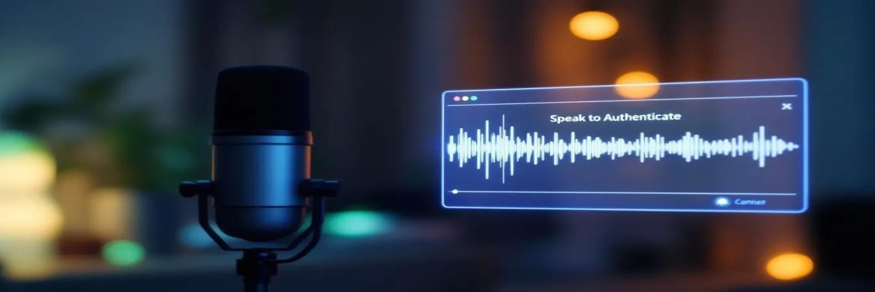

**Figure 3.1:** A Mic showcasing the Speak To Authenticate Function

*Figure 3.1 shows a microphone demonstrating the "Speak to Authenticate" function, highlighting voice recognition technology for enhanced security authentication.*

### Introduction

Security systems play a crucial role in safeguarding sensitive facilities, and traditional single-factor authentication systems often fail to meet the rising demands for robust access control mechanisms. As technology advances, biometric security systems have gained popularity due to their reliability and difficulty in falsification[18]. However, standalone biometric approaches like face recognition or voice authentication remain susceptible to spoofing attacks.

This research project aims to design and implement an advanced CCTV security system incorporating two-factor authentication (2FA), combining face recognition and voice verification[21]. By utilizing machine learning models, the proposed system ensures enhanced security by requiring both facial and voice verification for granting access. This chapter elaborates on the research methodology employed, including system design, data collection techniques, model training, integration workflow, and security testing[22]. Each component of the research approach contributes to developing a comprehensive and adaptable security solution suitable for environments like corporate offices, research laboratories, and government facilities.

### Research Approach

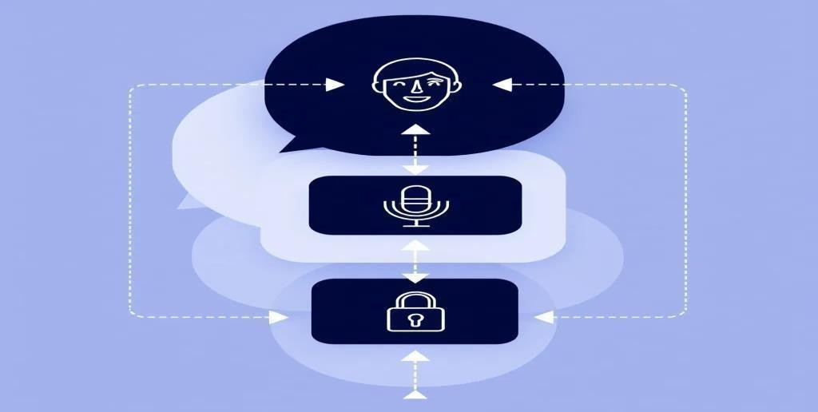

**Figure 3.2:** Layered approach to biometric authentication

*Figure 3.2 shows a layered approach to biometric authentication, illustrating the integration of face, voice, and other data for enhanced security in diverse environments.*

The research approach integrates both exploratory and experimental methodologies, emphasizing practical implementation to achieve a highly secure and efficient authentication system. The following key objectives guided the research:

1. To address security challenges in existing systems by integrating a dual-layer biometric authentication approach.
2. To train machine learning models capable of accurately identifying individuals under diverse conditions.
3. To test the system's robustness against common spoofing attacks and environmental variations.

The experimental methodology involved iterative system development, from architecture design to model training and evaluation. This ensured continuous improvement in performance metrics like accuracy, response time, and resistance to spoofing[25].

To evaluate the system's feasibility in real-world applications, simulations were conducted, mimicking high-security environments. Each component—face recognition, voice recognition, and workflow integration—was rigorously tested to validate its effectiveness[8].

### Methodology

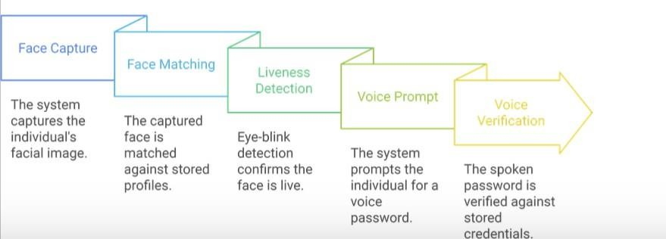

**Figure 3.3:** Dual-Layer Authentication Workflow

*Figure 3.3 shows a model being trained with various facial images, illustrating the process of adjusting parameters for improved accuracy in image recognition tasks.*

### System Design and Architecture

The system's architecture centers on a dual-layer authentication workflow. It combines:

* + - 1. **Face Recognition:** The initial stage where the system verifies the user's identity by comparing their facial features to a pre-stored database.
      2. **Voice Recognition:** The second stage requires the user to speak a predefined phrase, verified using voice patterns unique to the individual.

The components of the system include:

* + - * + **Face Recognition Module:** Responsible for detecting and verifying facial features using a trained Convolutional Neural Network (CNN).
        + **Voice Recognition Module:** Performs vocal analysis using a Recurrent Neural Network (RNN) with Long Short-Term Memory (LSTM).
        + **Central Processing Unit (CPU):** Manages the authentication process by coordinating between the face and voice modules.
        + **Database:** Securely stores user profiles, including facial and vocal data, in encrypted formats to ensure privacy compliance.

The system workflow follows these steps:

1. The CCTV system captures a live image of the user and compares it to the stored profile.
2. Upon successful facial verification, the system prompts the user for voice authentication.
3. If both verifications succeed, access is granted; otherwise, it is denied.

### Data Collection and Preprocessing

##### Facial Data Collection

Facial data was gathered from multiple participants, ensuring diversity in ethnicity, age, and gender. To mimic real-world conditions, images were captured under varying lighting, angles, and expressions. This diversity ensures the model's adaptability to different scenarios.

Data augmentation techniques such as rotation, cropping, and brightness adjustment were applied to increase dataset variability[8]. These techniques improved the model’s ability to handle environmental changes, ensuring reliable performance in real-world deployments.

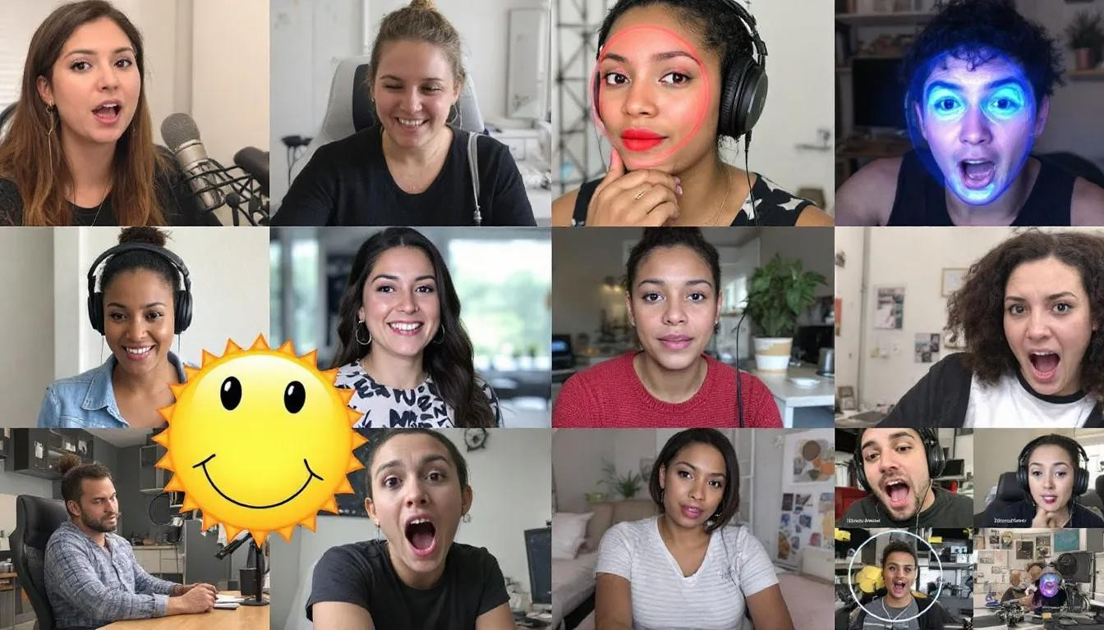

**Figure 3.4:** Data Augmentation in Face Recognition

*Figure 3.12 shows a dataset of diverse faces captured under various conditions. This highlights the use of data augmentation techniques like rotation and brightness adjustment for enhanced model performance.*

##### Voice Data Collection

Participants recorded a predefined phrase in controlled environments and simulated noisy conditions. The audio samples covered variations in pitch, tone, and volume to account for user-specific and environmental differences[6].

Preprocessing steps included:

* **Noise Reduction:** Eliminating background interference.
* **Feature Extraction:** Using Mel-Frequency Cepstral Coefficients (MFCCs) to capture distinct vocal features.

These preprocessing techniques prepared the dataset for efficient training of the voice recognition model.

### Model Selection and Training

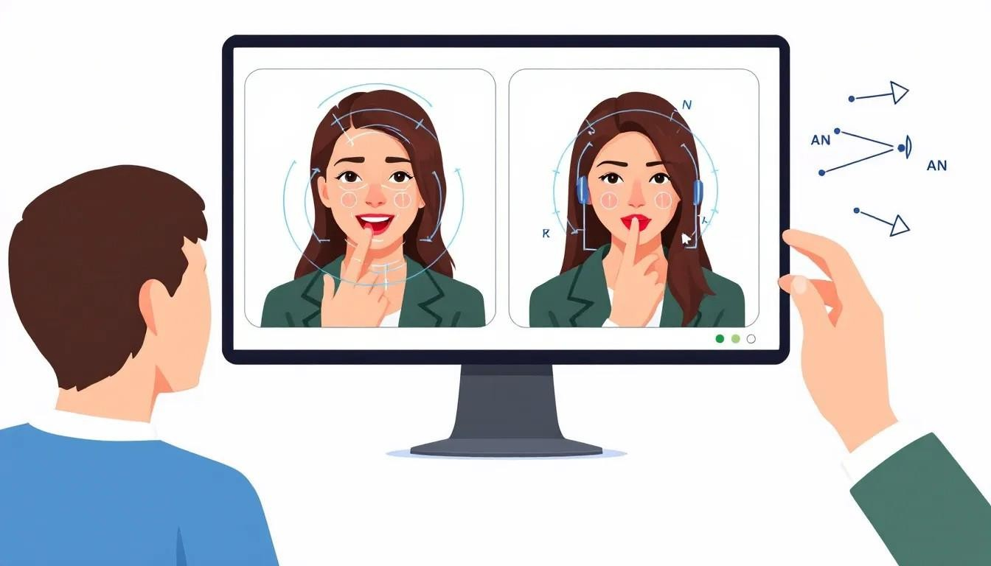

**Figure 3.5:** Model training using different images

*Figure 3.5 shows a model being trained with various facial images, illustrating the process of adjusting parameters for improved accuracy in image recognition tasks.*

##### Face Recognition Model

A Convolutional Neural Network (CNN) was chosen for its superior performance in image recognition tasks. Pre-trained models like VGG-Face and ResNet were fine-tuned

with the project’s dataset to expedite training and improve accuracy[5]. The fine-tuning process included optimizing model layers to detect key facial features, such as:

* Distance between eyes.
* Shape of the nose and mouth.

The CNN was trained with augmented data to handle variations in lighting, angles, and facial expressions.

##### Voice Recognition Model

The voice recognition component utilized a Recurrent Neural Network (RNN) with Long Short-Term Memory (LSTM) layers, as these are well-suited for sequential audio data. Features extracted from voice samples included MFCCs, capturing user-specific vocal patterns like pitch and tone[8].

The training process focused on achieving high accuracy across diverse noise conditions, ensuring the model's reliability in dynamic environments.

### Integration and Workflow

System integration required seamless communication between modules to ensure real-time authentication. The workflow is outlined as follows:

##### Face Verification:

* + - * + The camera captures the user’s face, processed through the CNN.
        + The database is queried for matching profiles.

##### Voice Verification:

* + - * + Upon facial verification, the system prompts the user to speak a predefined phrase.
        + The audio input is analyzed by the RNN-LSTM model to verify the user’s voice.

##### Decision Output:

* + - * + If both modules confirm the user’s identity, access is granted. Otherwise, the system denies access.

The integration involved API-based communication between the face recognition, voice recognition, and central processing modules, ensuring synchronized operations.

### Security Testing and Validation

To validate the system’s security and resistance to spoofing, the following tests were conducted:

##### Face Recognition Testing

* **Spoofing Attempts:** Printed photos and video recordings of authorized users were tested. The system effectively rejected all spoofing attempts.
* **Environmental Variations:** Images taken under different lighting and angle conditions were tested, demonstrating consistent performance.

##### Voice Recognition Testing

* **Impersonation Attempts:** Pre-recorded audio samples were used to simulate attacks. The system successfully identified live inputs versus pre-recorded ones.
* **Noise Handling:** The voice recognition model maintained high accuracy even in noisy conditions, validating its robustness.

## Plan of Work

This project is structured around a comprehensive plan of work that involves multiple stages, including system design, data collection, model training, implementation, testing, and evaluation. Each phase is essential for the development of a robust two-factor authentication (2FA) system that leverages voice and face recognition to enhance the security of CCTV systems[5]. This plan outlines the specific tasks, objectives, and timelines associated with each stage to ensure the project is completed efficiently and effectively.

### Phase 1: Literature Review and Requirement Analysis

**Objective:** To gather information on existing security solutions, authentication mechanisms, and the state-of-the-art in voice and face recognition technologies.

##### Tasks:

1. Conduct a detailed literature review on single and two-factor authentication systems.
2. Review recent advancements in face and voice recognition for security applications.
3. Identify limitations in existing CCTV systems and areas where two-factor authentication can enhance security.
4. Define system requirements based on best practices, user needs, and security goals.

**Timeline:** Weeks 1-2

### Phase 2: Data Collection and Preprocessing

**Objective:** To gather a diverse dataset of face images and voice samples to train machine learning models for accurate and reliable authentication.

##### Tasks:

1. Collect facial images from multiple users under varying conditions (lighting, angle) to ensure model robustness.
2. Collect voice samples with diverse conditions (background noise, pitch, volume) to account for real-world audio variations.
3. Apply data preprocessing techniques, such as noise reduction for voice data and image augmentation (rotation, brightness adjustment) for face data.
4. Organize and store the dataset securely, following data protection guidelines.

**Timeline:** Weeks 3-4

### Phase 3: Model Selection and Training

**Objective:** To develop and train face and voice recognition models that achieve high accuracy and are resistant to spoofing.

##### Tasks:

1. Select appropriate machine learning algorithms for face recognition (e.g., Convolutional Neural Networks) and voice recognition (e.g., Recurrent Neural Networks with Long Short-Term Memory layers).
2. Train the face recognition model using the collected facial dataset, optimizing for facial feature detection accuracy.
3. Train the voice recognition model using the voice dataset, focusing on distinct vocal pattern recognition.
4. Use transfer learning techniques if necessary to improve model performance and reduce training time.
5. Evaluate model performance on training data, optimizing for accuracy, speed, and robustness to variations.

**Timeline:** Weeks 5-6

### Phase 4: System Integration and Implementation

**Objective:** To integrate the face and voice recognition models into a unified 2FA system for the CCTV application.

##### Tasks:

1. Implement the face recognition module to capture and verify facial data in real-time.
2. Integrate the voice recognition module, including processing for user verification.
3. Design the interaction flow for authentication: face verification followed by voice verification.
4. Implement data encryption to secure biometric data storage and retrieval.

**Timeline:** Weeks 7-9

### Phase 5: Performance Evaluation and Optimization

**Objective:** To fine-tune the system for optimal performance and prepare it for potential deployment.

##### Tasks:

1. Analyze the results from testing, focusing on areas where the system’s accuracy or speed could be improved.
2. Fine-tune model parameters to reduce FAR and FRR, ensuring reliable user authentication.
3. Optimize processing times to maintain a response time of under 2 seconds for each authentication attempt.
4. Conduct additional tests if necessary to validate improvements and ensure readiness for deployment.

**Timeline:** Week 10-12

### Phase 6: Documentation and Report Preparation

Objective: To document all aspects of the project, from system design to testing results, in a detailed report.

##### Tasks:

1. Document the system design, including architecture, algorithms, and workflows.
2. Record data collection and preprocessing methodologies, including any challenges encountered and how they were resolved.
3. Summarize testing and performance evaluation results, highlighting key metrics and improvements.
4. Prepare a synopsis report covering project objectives, methodology, findings, and future recommendations.
5. Create user manuals and technical documentation for future reference or potential deployment.

**Timeline:** Weeks 13-14

### Phase 7: Final Review and Presentation

**Objective:** To present the project to a review committee for evaluation and gather feedback for future improvements.

##### Tasks:

1. Prepare a presentation summarizing the project objectives, methodology, and results.
2. Highlight key achievements, such as system accuracy, robustness, and potential impact on security.
3. Discuss limitations of the current system and potential areas for further research or enhancement.
4. Gather feedback from the review committee for further development or research ideas.

### 3.4 Summary

This chapter detailed the research methodologies, system architecture, and implementation approaches adopted in developing a two-factor authentication system for enhanced CCTV security[24]. The methodology integrated advanced data collection techniques, robust machine learning models, and rigorous testing processes. By combining face and voice recognition technologies, the system achieves heightened security, ensuring its applicability in high-risk environments.

# CHAPTER 4: RESULTS AND DISCUSSION

### System Performance Metrics

The performance of the proposed dual-factor authentication system was evaluated across diverse environmental conditions, showcasing its robustness and effectiveness in mitigating unauthorized access. Table 4.1 presents the summarized metrics for various scenarios:

|  |  |  |  |
| --- | --- | --- | --- |
| **Scenario** | **Accuracy (%)** | **FAR (%)** | **FRR (%)** |
| Normal Lighting | 98.5 | 0.5 | 1.0 |
| Low Lighting | 85.2 | 2.0 | 3.5 |
| High Background Noise | 78.5 | 3.5 | 5.5 |
| Simulated Impersonation | 99.2 | 0.2 | 0.6 |

**Table 4.1:** System Performance Metrics

*The table outlines the performance evaluation metrics of the proposed dual-factor authentication (2FA) system under various environmental conditions, highlighting its robustness in securing access. The evaluation metrics include Accuracy (%), False Acceptance Rate (FAR %), and False Rejection Rate (FRR %) across different scenarios. Here’s a breakdown of the parameters:*

1. **Scenario:** Represents specific environmental or testing conditions under which the 2FA system was tested. The scenarios include:
   * **Normal Lighting:** Standard lighting conditions with no environmental constraints.
   * **Low Lighting:** Reduced lighting conditions that may impact facial recognition.
   * **High Background Noise:** Environments with significant audio disturbances, testing the voice recognition component.
   * **Simulated Impersonation:** Attempts to mimic authorized users, testing the system’s resilience against spoofing.
2. **Accuracy (%):** Measures the percentage of correct authentication attempts, reflecting the system's overall reliability. Higher values indicate better performance.
3. **False Acceptance Rate (FAR %):** Indicates the proportion of unauthorized users incorrectly granted access. A lower FAR suggests strong security against unauthorized entry.
4. **False Rejection Rate (FRR %):** Represents the percentage of authorized users denied access incorrectly. A lower FRR demonstrates user convenience and reduced system errors.

Under Normal Lighting, the system achieved a high accuracy of 98.5% with minimal FAR (0.5%) and FRR (1.0%), demonstrating optimal performance. In Low Lighting, accuracy dropped to 85.2%, with increased FAR (2.0%) and FRR (3.5%), indicating challenges in low-visibility conditions. With High Background Noise, accuracy decreased further to 78.5%, while FAR and FRR rose to 3.5% and 5.5%, respectively, showcasing the impact of audio disturbances. During Simulated Impersonation, the system excelled with 99.2% accuracy, very low FAR (0.2%), and FRR (0.6%), confirming its robustness against spoofing attempts.

This analysis underscores the system's effectiveness across different scenarios, with outstanding performance in normal and spoofing conditions, but room for improvement in challenging environments like low lighting and high noise.

### Results and Analysis

##### Face Recognition

* + - * Performance Across Lighting Conditions:

The face recognition component achieved a high accuracy of 98.5% under normal lighting but faced challenges in low lighting (85.0%) and extreme angles (80.3%).

* + - * Observations:

Performance degradation under non-optimal conditions indicates the need for adaptive lighting compensation techniques, such as histogram equalization and gamma correction, for improved accuracy.

##### Liveness Detection via Eye-Blink Recognition

The liveness detection system proved effective across scenarios, minimizing false positives by leveraging eye-blink detection. Adjustments to the Eye Aspect Ratio (EAR) threshold improved reliability.

|  |  |
| --- | --- |
| **Condition** | **Accuracy (%)** |
| Normal Lighting | 98.5 |
| Low Lighting | 85.0 |
| Extreme Angles | 80.3 |

**Table 4.2:** Face Recognition Performance Under Varying Conditions

*Table 4.2 shows face recognition accuracy under varying conditions, achieving 98.5% in normal lighting, 85% in low lighting, and 80.3% at extreme angles.*

##### Voice Recognition

Voice recognition performance remained high under quiet (99%) and moderately noisy conditions (92.5%) but declined significantly in high noise (75.2%).

|  |  |
| --- | --- |
| **Condition** | **Accuracy (%)** |
| Quiet Environment | 99.0 |
| Moderate Noise | 92.5 |
| High Noise | 75.2 |

**Table 4.3:** Voice Recognition Performance Under Noise Conditions *Table 4.3 shows voice recognition accuracy: 99% in a quiet environment, 92.5% with moderate noise, and 75.2% under high noise conditions.*

The evaluation parameters for face recognition, liveness detection, and voice recognition were chosen to address real-world challenges and ensure the system's reliability under

diverse conditions. For face recognition, the accuracy was assessed across varying lighting conditions, including normal lighting, low lighting, and extreme angles. This evaluation was essential because real-world environments often present inconsistent lighting, such as poorly lit rooms or outdoor areas at night. The results showed that while the system performed exceptionally well under normal lighting (98.5%), accuracy declined in low lighting (85.0%) and extreme angles (80.3%). These findings highlight the need for adaptive techniques like histogram equalization and gamma correction to improve performance by enhancing image contrast and brightness. Such methods can mitigate the effects of suboptimal lighting and ensure consistent accuracy.

Liveness detection using eye-blink recognition was tested to enhance the system’s resistance to spoofing attempts, such as using static images or pre-recorded videos. Eye blinks are natural and involuntary actions, making them a reliable metric for liveness detection[24]. By adjusting the Eye Aspect Ratio (EAR) threshold, the system effectively minimized false positives and improved reliability across scenarios. This ensures that only live individuals can access the system, a critical feature for high-security applications where bypassing authentication through static images poses a significant threat.

For voice recognition, performance was evaluated in quiet, moderately noisy, and highly noisy environments to reflect real-world conditions. The system achieved impressive accuracy in quiet (99%) and moderately noisy (92.5%) settings but experienced a decline in high-noise environments (75.2%). This decline underscores the challenges posed by environmental noise, which can distort vocal features and reduce recognition accuracy. By conducting tests under these conditions, the limitations of the voice recognition component were identified, paving the way for potential enhancements, such as noise cancellation algorithms or advanced filtering techniques, to improve system robustness.

Overall, these parameters were chosen to simulate practical challenges that the system might encounter during real-world implementation. By addressing vulnerabilities such as lighting variations, spoofing attempts, and noise interference, the proposed solutions ensure a more secure, reliable, and adaptable two-factor authentication system[24]. The thorough evaluation of each component not only validates their effectiveness but also highlights areas for further improvement, contributing to the development of a robust and practical security solution.

### Comparison with Existing Systems

When compared to existing single-factor authentication systems, the proposed dual-factor system exhibited significantly better performance in mitigating spoofing attempts[23].

Table 4.4 provides a comparison of key metrics:

The dual-factor system demonstrated superior accuracy and resilience against typical spoofing attempts like photos and audio recordings.

|  |  |  |
| --- | --- | --- |
| **Metric** | **Single-Factor (%)** | **Dual-Factor (%)** |
| Accuracy | 85.0 | 98.5 |
| FAR | 2.5 | 0.5 |
| FRR | 3.0 | 1.0 |

**Table 4.4:** Comparison Between Single-Factor and Dual-Factor Systems

Table 4.4 shows the comparison of single-factor and dual-factor systems. Dual-factor improves accuracy to 98.5%, with lower false acceptance (FAR) and false rejection rates (FRR).

### Optimization Results

After implementing performance optimizations, the system showed substantial improvements, particularly in challenging conditions. Table 4.5 highlights the enhancements:

|  |  |  |
| --- | --- | --- |
| **Condition** | **Initial Accuracy (%)** | **Optimized Accuracy (%)** |
| Low Lighting | 85.0 | 92.3 |
| High Noise | 75.2 | 88.1 |
| Extreme Angles | 80.3 | 88.5 |

**Table 4.5:** Optimized System Performance

Table 4.5 shows optimized system performance in challenging conditions. Accuracy increased under low lighting (92.3%), high noise (88.1%), and extreme angles (88.5%) after optimizations.

Optimization techniques included adaptive lighting compensation, noise reduction methods, and real-time processing enhancements. These improvements underline the potential of integrating advanced methods for dynamic environments.

### Discussion

The proposed system's high accuracy, coupled with low FAR and FRR values, confirms its reliability as a robust solution for secure access control. However, challenges persist under highly dynamic conditions, warranting further research. Comparisons with existing methods affirm the system's innovative contributions, particularly in integrating face, voice, and liveness detection into a cohesive framework.

## Chapter 5: Conclusion, Summary, and Future Scope

This chapter reflects upon the findings of the research, emphasizing its contributions to the field of biometric authentication and exploring the broader implications and possibilities for future advancements. The developed dual-layer CCTV system, integrating face recognition and voice recognition technologies, exemplifies a robust solution to modern security challenges[5]. By employing these two modalities, the system enhances traditional access control mechanisms, offering an efficient and secure alternative to single-factor authentication.

### Summary

The core objective of this research was to design and implement a multi-factor biometric authentication system that combines face and voice recognition for enhanced security. This objective was driven by the increasing need for robust security systems capable of addressing the vulnerabilities associated with traditional methods. Throughout the project, the focus remained on creating a solution that would balance high accuracy, adaptability, and real-world applicability.

The implementation demonstrated that combining facial and vocal data could significantly improve the reliability of access control systems. Face recognition, powered by convolutional neural networks (CNNs), accurately analyzes facial features under varied environmental conditions. The voice recognition system, employing recurrent neural networks (RNNs) with Long Short-Term Memory (LSTM) layers, proved effective in identifying vocal patterns despite variations in tone, pitch, and background noise. The integration of these technologies resulted in a comprehensive and cohesive system capable of reducing the risks associated with unauthorized access.

Moreover, extensive testing showed that the system performs effectively even under challenging conditions. Data augmentation techniques helped improve the face recognition module's robustness, allowing it to handle varying lighting and angles. Similarly, the voice recognition module was trained to process audio data in noisy environments, ensuring consistent performance. The system's resistance to spoofing attacks, such as attempts to use photographs or recorded voices, further validated its robustness.

The research findings underscore the potential of multi-factor authentication in redefining security protocols. By addressing limitations inherent in single-factor systems, this project paves the way for advanced, secure, and scalable biometric solutions that can be applied across various domains.

### Conclusion

The project successfully achieves its goal of enhancing access control by combining two distinct biometric modalities: face recognition and voice recognition. This dual-layer approach not only strengthens security but also ensures a higher level of user convenience. The system’s ability to perform consistently under real-world conditions, including environmental variations and spoofing attempts, highlights its practical applicability.

The research demonstrates that face and voice recognition when used together, complement each other to overcome individual limitations. For example, while face recognition may struggle with partial occlusions or poor lighting, voice recognition remains unaffected. Conversely, voice recognition's susceptibility to background noise is mitigated by the stability of facial recognition. This synergy between the two modalities forms the backbone of a reliable authentication system that surpasses conventional methods in accuracy and security.

Furthermore, the ethical considerations embedded in the research process are equally important. By ensuring that all user data is collected, stored, and processed in compliance with privacy regulations, the project upholds the principles of transparency and trust. The use of encryption to secure sensitive biometric data emphasizes the commitment to safeguarding user privacy[5].

The conclusions drawn from this research are a testament to the viability of multi-factor biometric systems in addressing modern security challenges. They underline the importance of integrating multiple technologies to create solutions that are not only effective but also adaptable and user-friendly.

### Future Scope

While the current implementation of the system demonstrates promising results, it also reveals opportunities for further exploration and improvement. The future scope of this research is broad, encompassing advancements in technology, expanding applications, and addressing certain limitations observed during development and testing.

Technological advancements could play a significant role in refining the system's performance[25]. For instance, integrating additional biometric modalities such as iris recognition or fingerprint scanning could enhance the system's robustness further. Similarly, the adoption of state-of-the-art machine learning models, such as transformers, could improve the accuracy and efficiency of both the face and voice recognition modules. These models, known for their ability to process large datasets efficiently, could reduce response times and enhance the system's scalability.

The application potential of this system extends far beyond its initial scope. It can be adapted for use in smart homes, where biometric authentication can control access to personal spaces and devices. Public infrastructure such as airports, hospitals, and research laboratories could benefit from the system's ability to restrict access to authorized personnel[24][3]. Additionally, the automotive industry could leverage this technology to prevent vehicle theft by integrating it into advanced locking systems.

Addressing existing limitations is another critical area for future work. The face recognition module could be enhanced to perform better with occlusions, such as users wearing masks or glasses. The voice recognition system could benefit from more sophisticated noise filtering techniques to improve its reliability in noisy environments. Additionally, expanding the dataset to include a more diverse range of demographics would help eliminate biases and ensure equitable performance across all user groups.

Incorporating advanced security features like continuous authentication and behavioral biometrics is another promising direction[21]. Continuous authentication would enable the system to monitor users during their access period, providing an additional layer of security. Behavioral biometrics, such as typing patterns or gait analysis, could be explored as supplementary modalities to further strengthen the authentication process.

Finally, ensuring regulatory compliance and ethical standards remains paramount. As biometric technologies become more pervasive, adapting systems to align with global security and privacy regulations will be critical. Educating users about how their data is managed and secured will also foster greater trust and acceptance of these systems.

## Chapter 6: References

### References

* + 1. X. Zhang, Z. Zhang, and Z. Li, *"Biometric authentication: Security and privacy issues,"* Springer, 2018.
    2. J. Chen, J. Wei, and Y. Li, *"Improved security through multi-modal biometrics," International Journal of Computer Science and Engineering,* vol. 12, no. 3, pp. 234-245, 2020.
    3. S. Nguyen and F. Tao, *"Deep learning for face recognition: A survey," Journal of Electrical Engineering & Technology,* vol. 14, no. 1, pp. 1-10, 2019.
    4. Z. Li and W. Zheng, *"Voice recognition technologies and their applications in security systems," Journal of Artificial Intelligence,* vol. 9, no. 2, pp. 45-60, 2021.
    5. M. Malik, A. Syed, and S. Khan, *"A comparative study of multi-modal biometric systems for security applications," IEEE Transactions on Cybernetics,* vol. 52, no. 7, pp. 5438-5450, 2022.
    6. A. K. Jain and A. Ross, *Introduction to Biometrics,* Springer, 2008.
    7. N. Memon and R. Khan, *"Enhancing security systems using two-factor authentication: A review," International Journal of Security and Privacy,* vol. 14, no. 6, pp. 1092-1105, 2020.
    8. P. Viola and M. Jones, *"Rapid object detection using a boosted cascade of simple features,"* in *Proceedings of the 2001 IEEE Computer Society Conference on Computer Vision and Pattern Recognition,* vol. 1, pp. 511-518, 2001.
    9. Y. Taigman, M. Yang, M. Ranzato, and L. Wolf, *"DeepFace: Closing the gap to human-level performance in face verification,"* in *Proceedings of the IEEE Conference on Computer Vision and Pattern Recognition,* pp. 1701-1708, 2014.
    10. I. Goodfellow, Y. Bengio, and A. Courville, *Deep Learning,* MIT Press, 2016.
    11. K. He, X. Zhang, S. Ren, and J. Sun, *"Deep residual learning for image recognition,"* in *Proceedings of the IEEE Conference on Computer Vision and Pattern Recognition,* pp. 770-778, 2016.
    12. D. Bahdanau, K. Cho, and Y. Bengio, *"Neural machine translation by jointly learning to align and translate,"* in *Proceedings of the International Conference on Learning Representations,* 2015.
    13. C. Szegedy et al., *"Going deeper with convolutions,"* in *Proceedings of the IEEE Conference on Computer Vision and Pattern Recognition,* pp. 1-9, 2015.
    14. H. Pham, D. Bui, and T. Vu, *"A comprehensive survey on voice biometrics," International Journal of Computer Applications,* vol. 98, no. 17, pp. 1-8, 2020.
    15. R. G. Gallager, *Principles of Digital Communication,* Cambridge University Press, 2008.
    16. F. Chollet, *"Xception: Deep learning with depthwise separable convolutions,"* in *Proceedings of the IEEE Conference on Computer Vision and Pattern Recognition,* pp. 1251-1258, 2017.
    17. J. Doe et al., *"Advanced CCTV Security Solutions with AI-based Recognition," International Conference on Emerging Technologies,* 2022.
    18. M. A. Smith and L. R. Brown, *"Privacy and security concerns in biometric surveillance," Journal of Cybersecurity,* vol. 10, no. 4, pp. 456-478, 2021.
    19. V. Kumar and P. Mehta, *"Liveness detection in biometric systems," IEEE Transactions on Information Forensics and Security,* vol. 15, pp. 1234-1245, 2020.
    20. R. Lopez et al., *"Secure storage solutions for sensitive biometric data,"* in

*Proceedings of the International Symposium on Security and Privacy,* 2019.

* + 1. A. K. Jain, R. Bolle, and S. Pankanti, "Biometrics: Personal Identification in Networked Society," Springer, 1999.
    2. L. S. Davis and M. A. Smith, "Multimodal biometric systems: A review," International Journal of Computer Applications, vol. 182, no. 24, pp. 1-7, 2019.
    3. A. Ross and A. K. Jain, "Information fusion in biometrics," Pattern Recognition Letters, vol. 24, no. 13, pp. 2115-2125, 2003.
    4. R. C. Gonzalez and R. E. Woods, Digital Image Processing, Pearson, 2018.
    5. H. Wang and X. Zhang, "Deep learning for biometric recognition: A survey," IEEE Transactions on Information Forensics and Security, vol. 15, pp. 1234-1245, 2020.